PSSI Science Project Reporting Template

️ | The PSSI Implementation Team is compiling a technical report to demonstrate the important research and advancements made by the Science Branch through the PSSI funding. The technical report will include a 3-4 page summary (including graphics and figures) for each project to show their key results and findings. Please fill in the following fields and sections for your project to be included in the report. Feel free to include and draw from any reports or presentations previously created through your research.  A plain language science bulletin will also be created to follow up on last year’s “DFO Pacific Region Science Bulletin, 2024. New research and monitoring for Pacific salmon and their ecosystems.” While the first bulletin introduced project backgrounds, methods, and timelines, this new bulletin will highlight the projects’ results, key findings, and conclusions with links to reports and data available. The bulletin will include a 1-2 page summary for each project gleaned from the content entered below.  ️ Completed forms are due January 7, 2026.  *Please include or send separately any graphics or pictures (with photo credits) that will help promote the projects.

PART 1: PROJECT METADATA

General Project Information
Project ID (number) | Project Title
2409 | Convergent tracks: a tagging study to quantify salmon predation by sea lions
Project Leads | Collaborations and External Partners
Cameron Freshwater and Strahan Tucker | Salmon: Justin Fleming and Jackie King (DFO ESD), Erin Rechisky (DFO South Coast Stock Assessment), Andy Seitz and Michael Courtney (University of Alaska Fairbanks)  Sea lions: Chad Nordstrom, Ali Bowker, Sheena Majewski, Kurt Trzcinski (DFO ESD), Marty Haulena (Vancouver Aquarium), Christine Rock (ECCC)
Location (if applicable)
Click or tap here to enter text.

Geographic and Stock Information
Salmon species (if applicable) | Waterbodies (if applicable)
Sockeye salmon | Continental shelf, Queen Charlotte Strait, Johnstone Strait, Strait of Georgia
Life history phases (if applicable) | Region
Adult marine | BC coast
Stock (if applicable) | Population (if applicable)
Fraser River | Click or tap here to enter text.
Conservation Unit (if applicable)
Chilko dominant

🧰 PART 2: PROJECT METRICS

Project Outputs
Include any anticipated outputs denoted as (in progress). Please include links to any outputs available online so they can be referenced in the report.
List scientific publications and technical reports (with links)
- Fleming, J., King, J.R., Tucker, S., and C. Freshwater 2025. Acoustic and Satellite Tagging of Sockeye Salmon, Oncorhynchus nerka, Off the West Coast of Haida Gwaii, September 30 – August 11, 2024. Canadian Data Report of Fisheries and Aquatic Sciences 1441, 16 p. Fs97-13-1441-eng.pdf
- Primary publication summarizing sockeye salmon mortality rates and predator vectors (in progress)
- Tech report summarizing sockeye salmon behaviour (in progress)
- Primary publication summarizing Steller sea lion distribution (analysis underway)
- Primary publication summarizing Steller sea lion diet (analysis underway)
- Primary publication synthesizing salmon and sea lion data streams to quantify predation risk (anticipated)
List datasets generated (with links)
Click or tap here to enter text.
Describe dataset locations and data management systems
- Sockeye acoustic and satellite telemetry, biological, and catch data will be posted to GitHub once QA/QC complete
- Steller sea lion satellite telemetry, biological, and diet data will be posted to GitHub once QA/QC complete

List code, programs, or other software created (with links)
Click or tap here to enter text.
List communication or social media products
Presentation in PSSI Symposium on Dec. 4, 2025
List and describe field work completed
- More than 40 acoustic receivers deployed, per year, from charter vessels along the west coast of Haida Gwaii, Triangle Island, Queen Charlotte Strait, and the Strait of Georgia
- Nearly 700 sockeye salmon sampled for length and genetics prior to release from charter purse seine vessel along west coast Haida Gwaii (2024/25) and Queen Charlotte Strait (2025)
- 625 sockeye salmon tagged with acoustic transmitters
- 34 sockeye salmon tagged with satellite transmitters
- 21 adult Steller sea lions were tagged on Triangle Island (15 females 2024 & 2025; 7 males 2025)
- Between 2023-2025, nearly 400 biopsies samples were obtained directly from satellite tagged animals and random draws by crossbow for fatty acid (FA) and stable isotope analysis (SI); results for 2025 pending
- For unknown animals, sex determined by genetic analysis (PBS Molecular Genetics Lab) to define sex differences in foraging behaviour and diet
- Will use validated epigenetic clock to generate discrete age estimates (UBC-Kobor lab) to define ontogeny in foraging behaviour and diet
- To establish baselines for diet estimation, nearly 1500 samples of potential obtained 2023-2025 from DFO Integrated Pelagic Ecosystem Survey and Groundfish surveys and analyzed for FA and SI; results for 2025 pending
- 1200 scats were collected concurrently with biopsy sampling. However, due to financial constraints, these samples are currently archived for potential future analysis
List and describe samples collected/analyzed (number of samples)
See above
List and describe large capital assets or equipment acquired
N/A

PART 3: WRITTEN CONTENT

Highlights
Please summarize in 2-3 bullets:
- The main idea of the project
- Key findings
- Implications of these findings for salmon and decision-makers
- For a more technical audience, but still as plain language as possible
- Increased predation by Steller sea lions (SSL) has been identified as a potential cause of declines in Fraser River sockeye salmon abundance; however, there were previously no relevant data on SSL diets and distribution or sockeye salmon mortality rates to test the hypothesis.
- We found evidence of high sockeye salmon mortality rates; however, the majority of mortality was associated with salmon sharks, not SSL. The SSL predation that did occur was concentrated in Queen Charlotte Strait, not the largest rookery at Triangle Island. While SSL diet results are pending, SSL tagging data demonstrated evidence of restricted foraging during the initial portion of sockeye salmon migration (as animals are tied to breeding/pupping rookery) followed by rapid dispersal (particularly by males) away from Triangle Island and diverse foraging strategies among individuals. Widespread overlap of the SSL stock with migrating Fraser River sockeye salmon appears to be less than presumed.
- Collectively, these results suggest sockeye salmon may be vulnerable to a broader range of predators than previously considered, and that predator communities, and predation risk, vary through space and time. Thus, previous estimates of SSL consumption rates may be biased high.

Background
Please provide 1-2 paragraphs to summarize
- The relevant biological, environmental, and/or management context
- What knowledge gap or demand were you trying to fill?
- Collaboration and partner relationships
Fraser River sockeye salmon productivity has been poor since the early 1990s (Peterman and Dorner 2012). Although the mechanism remains unclear and is likely multifaceted (Cohen 2012), bottom-up processes that reduce juvenile marine survival have been identified as a likely factor (McKinnell et al. 2014, Freshwater et al. 2018, Rechisky et al. 2019). More recently, elevated predation of returning adult Fraser River sockeye salmon by Steller sea lions (SSL) has been hypothesized to be a key factor (Walters et al. 2020). The primary pieces of evidence used to infer SSL impacts are a) large increases in SSL population size coincident with Fraser River sockeye salmon declines, b) the location of large SSL breeding colonies proximate to sockeye migration corridors (e.g., Triangle Island rookery at the northwest tip of Vancouver Island is the largest in northeast Pacific), and c) bioenergetic modeling that estimated significant removals (>1 million individuals) by SSLs if sockeye are 40% of the diet during four weeks in summer and all SSLs at British Columbia rookeries target sockeye during this period (Walters et al. 2020). Yet because there are no published estimates of SSL diet nor foraging distribution from rookeries and haul outs adjacent to sockeye salmon migration corridors, our current understanding of SSL foraging ecology is insufficient to validate key model assumptions. Furthermore, previous empirical estimates of sockeye salmon survival during their marine migrations do not have sufficient resolution to evaluate SSL impacts (Crossin et al. 2007, 2009). As a result, the impact of SSL, and other marine predators, on Fraser River sockeye salmon remains uncertain.

️ Methods and Findings
Please insert a few paragraphs to summarize:
- Main methods used
- Products and tools produced
- Advancements in methodology, technology, and application
- Advancements in communication and knowledge transfer
- Key results and information generated
We used multiple methods to evaluate SSL foraging ecology, quantify sockeye salmon mortality rates, and ultimately draw inference on the likely impact of SSLs on migrating Fraser River sockeye salmon. The following activities occurred during the 2024 and 2025 field seasons (Figure 1).

Sockeye Salmon Methods
Sockeye salmon were captured aboard a charter purse seine vessel from sites near Rennell Sound (west coast Haida Gwaii; 2024 and 2025) and Queen Charlotte Strait (2025 only). Sockeye salmon were landed and transferred to a flow through seawater trough where biological data, including genetic stock identification (GSI) samples, were collected. Individuals in good physical condition were tagged with either an acoustic or satellite tag before being immediately released. We deployed acoustic transmitters on sockeye salmon (n=625) which allowed individuals to be detected on moored receiver arrays near Haida Gwaii, Triangle Island, Queen Charlotte Strait, throughout the Salish Sea, and the lower Fraser River. The acoustic receiver network included approximately 40 receivers deployed by DFO throughout coastal British Columbia, as well as infrastructure maintained by NOAA, the Ocean Tracking Network, Kintama, and the University of British Columbia. Detections data will be used to parameterize mark-recapture models to estimate survival rates along the migration corridor and identify hotspots of mortality. We also deployed popup archival satellite tags (PSATs) on a smaller number of sockeye salmon (n=35). After releasing from the animal these tags transmit light, temperature, and pressure sensor data that can be used to identify predator taxa (Seitz et al. 2019).

Sockeye Salmon Findings
GSI results are currently only available for the 2024 field season; however, the majority (>98%) of tagged sockeye salmon were identified as belonging to Fraser River populations with Chilko Lake being the dominant conservation unit (~55% of all samples). Only a subset of detections data are currently available for 2025; however preliminary results in both years (Figure 2) indicate overall survival from Haida Gwaii to the Fraser River was poor (<8%). ~50% of individuals tagged at northern sites were detected on Haida Gwaii arrays; however, mark-recapture models that account for imperfect detection probability on these arrays are required for robust estimates of survival. Survival to the Fraser River of tags deployed in Queen Charlotte Strait was markedly higher (~40%). 2% of tags were detected in the study area after deployments were completed, suggesting short-term mortality due to tagging or handling was minimal. Only two tags were detected at Triangle Island (both in 2025), however 46 tags were detected in 2025 at sea lion haul outs throughout Queen Charlotte Strait. Importantly, additional analysis is required to determine how many of these fish were likely consumed by pinnipeds based on subsequent detections. No fish were reported as intercepted by fisheries in 2024, but 5% of tagged fish were recaptured by marine and in-river fisheries and reported in 2025.

We deployed 18 PSATs at Haida Gwaii sites in 2024 and 17 in 2025 (ten in Haida Gwaii and seven in Queen Charlotte Strait). Six of the 2024 PSATs failed to report due to engineering issues. All of the remaining 12 reported before their programmed release data, suggesting the fish were predated. Of the confirmed mortalities, three could not be classified because the tag was not ingested, one was consumed by a benthic ectotherm, and eight were consumed by salmon sharks (Figure 3). In 2025, all PSATs reported and five survived to release, all from the Queen Charlotte Strait study area. Of the ten Haida Gwaii tags, four were consumed by blue sharks, three by a benthic ectotherm, and three by salmon sharks. Neither of the two Queen Charlotte Strait mortalities could be classified (Figure 3).

SSL Methods
We deployed satellite tags (paired head-mounted splash and flipper-mounted spot tags) on adult male (n=7) and female (n=14) SSLs on Triangle Island. Animals were sedated via darting gun and tagged with the assistance of staff from the Vancouver Aquarium. Females were captured near the end of July following pupping; males were captured at the beginning of June as animals staked out territories for the breeding period. Head mounted tags were epoxied to the fur and were shed by fall during the annual moult while the flipper mounted tags should stay affixed for multiple years although tag programming and battery life will ultimately determine transmission duration. The high resolution, yet shorter deployment splash tags will allow for an understanding of foraging behaviour (location and dive profiles) and sex-specific habitat use revealing explicit spatial-temporal overlap with sockeye salmon during their migration through Queen Charlotte Sound. This distribution data is critical in evaluating the relative proportion of the SSL population that has the opportunity to predate sockeye salmon. The longer-term flipper tags (8-16 months; multi-year) will allow for multi-season information on coarse foraging patterns.

We also collected SSL diet information via biochemical tracers and scats from sites on Triangle Island, as well as key haul outs in Queen Charlotte Strait, southwest coast of Vancouver Island, and the southern Strait of Georgia. The two biochemical tracers we have focused on, fatty acid profiles and stable isotopes, provide estimates of diet composition integrated over weeks to month. The fatty acid analysis (FAA; Budget et al. 2006) will provide more discrete diet estimation (prey-specific proportions) while the stable isotope analysis (SIA; Layman et al. 2012) will be useful to discriminate feeding source (pelagic vs demersal, nearshore vs shelf vs shelf break) such that we can broadly characterize foraging behaviour beyond the satellite tagged individuals. Diets estimated from scats provide a short-term (~ 1 day) estimate requiring far more extensive, repeated sampling to capture temporal variation in diet-particularly if the objective is to capture a potential pulse of a relatively rapidly migrating prey. While we collected scats (n=1,200), there was insufficient funding provided to analyze these, let alone undertake a full-fledged sampling design for scats. These are therefore archived for potential future work and analysis focused on the integrated tracer samples. In total, ~400 sea lion biopsy samples were obtained directly from satellite tagged animals or randomly via a crossbow system. To estimate diet, over 1500 potential fish and invertebrate prey samples were obtained from various DFO research cruises.

SSL Findings
During the 5 – 6-week deployments prior to moult, female foraging was concentrated on the continental shelf (Figure 4a). In the initial weeks, animals used Triangle Island as a central place for short foraging forays. As pups inevitably grew and became more independent, there was a gradual expansion and dispersal away from Triangle east to Cook Bank and Queen Charlotte Strait and south-east to Quatsino Sound with females ultimately moving to sites both east and south of Triangle Island. During the 14 – 16-week deployments prior to moult, males demonstrated very limited foraging activity during the breeding period (Figure 4b). Subsequently by mid-July there was rapid and directed dispersal immediately post-breeding with individuals ranging as far north as southeast Alaska and south to the Washington border. Triangle was not used as major haul out outside of the breeding period for either females or males. More in-depth analysis of distribution and dive behaviour is underway to explicitly parameterize sea lion foraging effort in a spatial context and provide support for interpreting diet results.

Stable isotope and fatty acid datasets for potential prey and sea lions have been completed for 2023-2024 samples; 2025 samples are currently being processed and analyzed. Preliminary analysis of 2023-2024 SI values for known age class and sex animals suggests that males and females are exploiting different prey/habitats diverging further with age (Figure 5).

Insights
Please insert a few paragraphs to summarize:
- What this project has added to knowledge about salmon populations, health, or ecosystems.
- How this project informs salmon management:
  - decisions
  - policy guidance
  - trade-offs
  - planning
- Addition of knowledge to understanding:
  - limiting factors/stressors/threats/ pathways of effects/risks
  - biologically significant thresholds
  - cumulative impacts
- Sources of uncertainty
Although analyses are underway, there are several key preliminary results. We found that sockeye salmon mortality rates during adult marine migrations may be considerably higher than previously assumed (e.g. Cohen 2012). At the same time, it is clear that the predator community varies along the migratory corridor—while we found some evidence of pinniped predation in Queen Charlotte Strait that warrants additional investigation, we found no evidence of pinniped predation near Haida Gwaii where mortality rates were high and apparently driven by shark predation. Similarly, we found evidence that predation impacts likely vary among and within sea lion haul outs. Despite the large size of the Triangle Island rookery, we found a very small number of tags at this location, particularly relative to Queen Charlotte Strait haul outs.

Steller sea lion satellite tag paths highlight important nuances in foraging behaviour during the months when Fraser River sockeye salmon are available. At this time of year, mature SSL are tied to pupping, nursing and breeding with only intermittent foraging. Peak pupping typically occurs early July. Females stay with their pups fasting for 1-2 weeks after which they make short foraging trips. Females appeared to disperse from Triangle by mid-August to other haul outs around Queen Charlotte Sound and WCVI. Males had very limited movements during the breeding period. Rapid and directed dispersal immediately post breeding (mid-July) was observed. Despite the large number of animals concentrated on Triangle Island during the breeding period (coincident with sockeye salmon migration), adjacent waters do not appear to be a major feeding ground this time of year. These foraging and dispersal patterns generally run counter to blanket assumptions for SSL impacts on sockeye and will have implications for foraging models. Ongoing diet analyses will provide additional information on individual, spatial, and seasonal variability in Steller sea lion foraging.

Our results emphasize the impacts of at least three predator taxa (salmon sharks, blue sharks, Steller sea lions) on sockeye salmon warrant additional consideration. Given a potential latitudinal gradient in shark abundance (Williams et al. 2010, Proudfoot et al. 2024), population level impacts may be sensitive to where Fraser River sockeye salmon intercept the continental shelf during their return migrations. All else being equal, fish making landfall near Haida Gwaii will migrate through a longer gauntlet of predators than those making landfall in Queen Charlotte Sound, which may in turn be at greater risk than those migrating through Juan de Fuca Strait. The location of landfall is uncertain, but if it is correlated with diversion rate, as seems likely, will vary among stocks as well as among years (Grant et al. 2017). If we find evidence of year-specific differences in survival rate, consistent with expected density dependent effects on predator foraging behaviour, this will add substantial additional variability due to sockeye salmon cyclicity. In short, a fixed, average predation rate applied to all stocks is likely inappropriate. Unfortunately, using statistical models to quantify the relative impact of each taxa is not possible given a lack of abundance data for blue and salmon sharks.

⏩ Next Steps
Please insert 1-2 paragraphs to summarize:
- Remaining knowledge gaps and recommendations for future studies
- How can/should the project findings be operationalized for salmon conservation and management?
Our findings highlight successful ecosystem-based management of sockeye salmon requires careful consideration of factors that are often overlooked when quantifying predator impacts. First, studies on predation impacts have focused on cetaceans and pinnipeds (Chasco et al. 2017a & b, Walters et al. 2020, Nelson et al. 2024), which have robust time series of abundance. However, the effect of pinniped impacts will be biased high if the abundance of multiple predator taxa have increased in synchrony. In this scenario, reducing cetacean or pinniped effects may simply result in the remaining predator taxa increasing in abundance. Second, bioenergetics models are commonly used to quantify the population level impact of predators (Chasco et al. 2017a & b, Walters et al. 2020); however, these methods are sensitive to assumptions about the relative contribution of different species and size classes to the diet (Nelson et al. 2021). These uncertainties are further amplified by seasonal and spatial variability in predator diets, as well as differences among individuals in foraging behaviour. Finally, the total impact on prey species is also sensitive to the proportion of the prey population that is vulnerable to predation. Our findings suggest that each of these components is highly relevant when evaluating Steller sea lion impacts on Fraser River sockeye salmon.

In particular, we suggest ongoing and future work should address the following major dimensions. Seasonal and spatial variability in Steller sea lion diets should be quantified—this work will proceed using collected biochemical tracers. Seasonal, sex-specific variability in Steller sea lion distributions should be used to estimate the relative proportion of the population that is likely to overlap spatially and temporally with migrating sockeye salmon—this work could proceed using existing satellite and overflight survey data. Steller sea lion distributions should be paired with estimates of interannual and stock-specific variability in sockeye salmon migration routes to evaluate relative risk—this work is proceeding using historical catch data, but it is currently unclear whether existing data are sufficient. Since salmon-predator interactions are highly context-dependent (Wells et al. 2025), until the above data gaps are addressed efforts to mitigate predator impacts should proceed with caution and a careful consideration of the associated uncertainties.

📈 Tables and Figures
Please provide captions and numbering for any tables and figures. Graphics can be copied below or e-mailed separately.
- Include a brief caption with each figure and table in the box below
- Number each table and figure, and include references in the above sections where appropriate.
- 1-3 figures are recommended per project
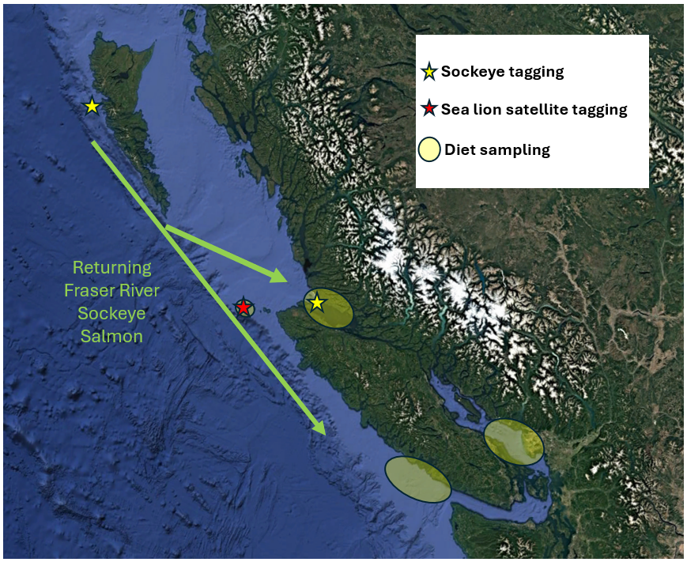
Figure 1. Map of study area showing approximate Fraser River sockeye salmon migration corridor, sockeye salmon and Steller sea lion tagging sites, and diet sampling locations.

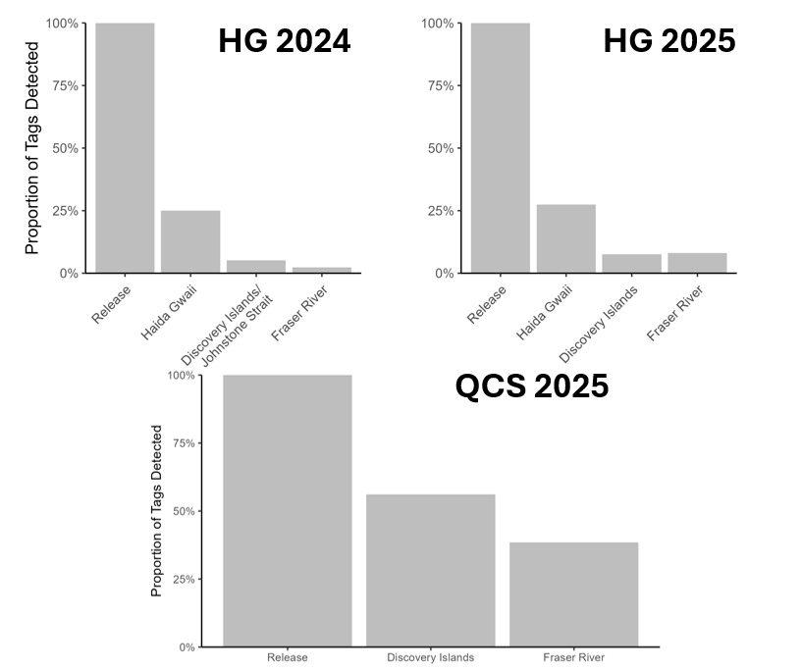
Figure 2. Proportion of tagged sockeye salmon detected along migration corridor by release cohort (HG is Haida Gwaii, QCS is Queen Charlotte Strait). Detections provide an approximate estimate of survival but do not account for imperfect detection probability. Final results require parameterization of mark-recapture model.

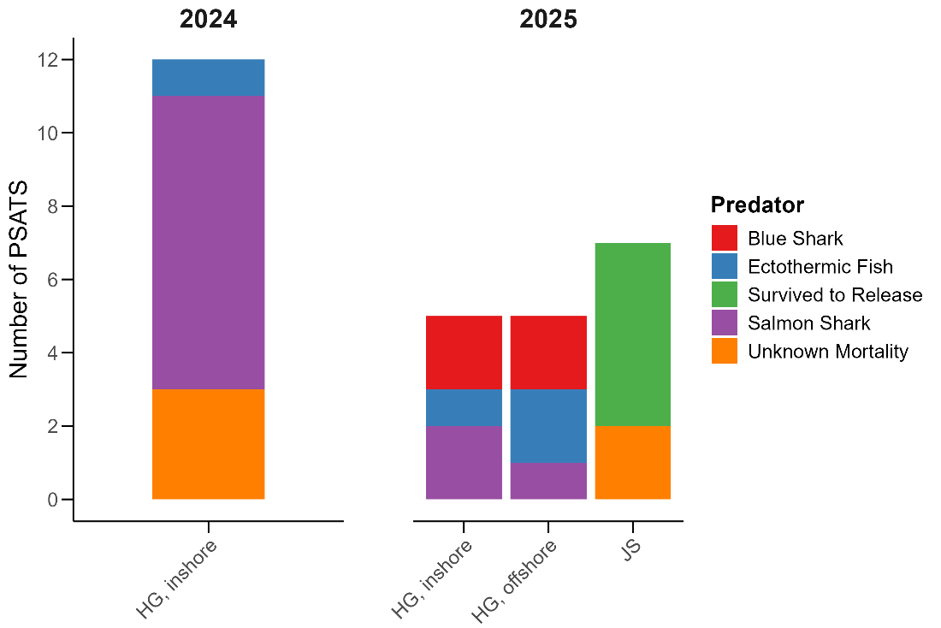

Figure 3. Fates of popup satellite tags stratified by release location. Survival to release represents tags that uploaded data at their release date. All other tags transmitted early indicating they were no longer attached to the tagged animal. Ingested tags could be assigned to a predator guild based on temperature and pressure data while unknown mortalities represent deployments where the tag was removed from the prey, but not ingested by a predator.

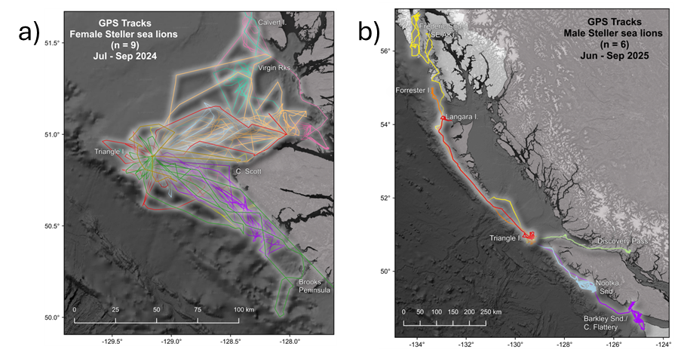
Figure 4. Tracks of individual a) female and b) male Steller sea lions satellite tagged on Triangle Island in 2024 or 2025.

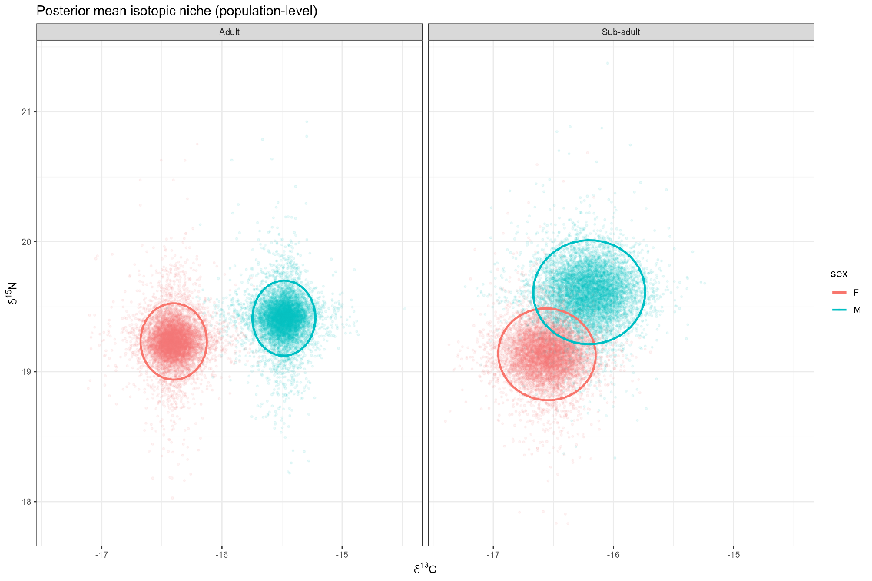

Figure 5. Posterior mean isotopic (δ¹³C and δ¹⁵N) space for Steller sea lions by age class and sex. Points represent draws from the posterior distribution of population-level mean isotope values from Bayesian hierarchical models. Ellipses denote 95% Bayesian credible regions of uncertainty in mean isotopic values for each group.

📈 References
Include full references for any publications referenced in other sections. Please format references in Harvard style according to Instructions to Authors for the Canadian Journal of Fisheries and Aquatic Sciences, at Canadian Science Publishing.
Budge, S.M., Iverson, S.J. and Koopman, H.N., 2006. Studying trophic ecology in marine ecosystems using fatty acids: a primer on analysis and interpretation. Marine Mammal Science, 22(4).

Chasco, B., Kaplan, I., Thomas, A., Acevedo-Gutiérrez, A., Noren, D., Ford, M., Hanson, M., Scordino, J., Jeffries, S., Marshall, K., Shelton, A., Matkin, C., Burke, B. & Ward, E. 2017a. Competing tradeoffs between increasing marine mammal predation and fisheries harvest of Chinook salmon. Scientific Reports, 7.

Chasco, B., Kaplan, I., Thomas, A., Acevedo-Gutiérrez, A., Noren, D., Ford, M., Hanson, M., Scordino, J., Jeffries, S., Pearson, S., Marshall, K. & Ward, E. 2017b. Estimates of Chinook salmon consumption in Washington State inland waters by four marine mammal predators from 1970 to 2015. Canadian Journal of Fisheries and Aquatic Sciences 74: 1173-1194.

Cohen, B. 2012. The Uncertain Future of Fraser River Sockeye Salmon Volume 2: Causes of the Decline. 212 p.

Crossin, G.T., Hinch, S.G., Cooke, S.J., Welch, D.W., Batten, S.D., Patterson, D.A., Van Der Kraak, G., Shrimpton, J.M., and Farrell, A.P. 2007. Behaviour and physiology of sockeye salmon homing through coastal waters to a natal river. Mar. Biol. 152: 905-918.

Crossin, G.T., Hinch, S.G., Cooke, S.J., Cooperman, M.S., Patterson, D.A., Welch, D.W., Hanson, K.C., Olsson, I., English, K.K., and Farrell, A.P. 2009. Mechanisms influencing the timing and success of reproductive migration in a capital breeding semelparous fish species, the sockeye salmon. Phys. Biochem. Zool. 82: 635-652.

Freshwater, C., Burke, B.J., Scheuerell, M.D., Grant, S.C.H., Trudel, M., and Juanes, F. 2018. Coherent population dynamic associated with sockeye salmon juvenile life history strategies. Can. J. Fish. Aquat. Sci. 75: 1346-1356.

Layman, C.A., Araujo, M.S., Boucek, R., Hammerschlag‐Peyer, C.M., Harrison, E., Jud, Z.R., Matich, P.,

Rosenblatt, A.E., Vaudo, J.J., Yeager, L.A. and Post, D.M., 2012. Applying stable isotopes to examine foodweb structure: an overview of analytical tools. Biological reviews, 87(3), pp.545-562.

McKinnell, S., Curchitser, E., Groot, K., Kaeriyama, M., and Trudel, M. 2014. Oceanic and atmospheric extremes motivate a new hypothesis for variable marine survival of Fraser River sockeye salmon. Fish. Ocean. 23: 322-341.

Nelson, B., Pearson, S., Anderson, J., Jeffries, S., Thomas, A., Walker, W., Acevedo-Gutiérrez, A., Kemp, I., Lance, M., Louden, A. & Voelker, M. 2021. Variation in predator diet and prey size affects perceived impacts to salmon species of high conservation concern. Canadian Journal of Fisheries and Aquatic Sciences 78: 1661-1676.

Nelson, B.W., McAllister, M.K., Trites, A.W., Thomas, A.C. and Walters, C.J. 2024. Quantifying impacts of harbor seal Phoca vitulina predation on juvenile Coho Salmon in the Strait of Georgia, British Columbia. Marine and Coastal Fisheries 16(1), p.e210271.

Peterman, R.M. and Dorner, B.D. 2012. A widespread decrease in productivity of sockeye salmon (Oncorhynchus nerka) populations in western North America. Can. J. Fish. Aquat. Sci. 69: 1255-1260.

Proudfoot, B., Thompson, P.L, Vaidyanathan, T., Robb, C.K. 2024. Spatial estimate of blue shark, salmon shark, Pacific sleeper shark, and bluntnose sixgill shark presence in British Columbia. Can. Tech. Rep. Fish. Aquat. Sci. 3600: 27 p.

Rechisky, E.L., Porter, A.D., Clark, T.D., Furey, N.B., Gale, M.K., Hinch, S.G., and Welch, D.W. 2019. Quantifying survival of age-2 Chilko Lake sockeye salmon during the first 50 days of migration. Can. J. Fish. Aquat. Sci. 76: 136-152.

Seitz, A.C., Courtney, M.B., Evans, M.D., and Manishin, K. 2019. Pop-up satellite archival tags reveal evidence of intense predation on large immature Chinook salmon (Oncorhynchus tshawytscha) in the North Pacific Ocean. Can. J. Fish. Aquat. Sci. 76: 1608-1615.

Walters, C.J., McAllister, M.K., and Christensen, V. 2020. Has Steller sea lion predation impacted survival of Fraser River sockeye salmon? Fish. 45: 597-604.

Wells, B.W., Huff, D.D., Quinn, T.P., Santora, J.A., Gomes D.G.E. et al. 2025. When, where, and why salmon become vulnerable to predation. ICES J. Mar. Sci. 82: fsaf162.

Williams, R., Okey, T.A., Wallace, S.S., Gallucci, V.F. 2010. Shark aggregation in coastal waters of British Columbia. Mar. Ecol. Prog. Ser. 414: 249-265.

